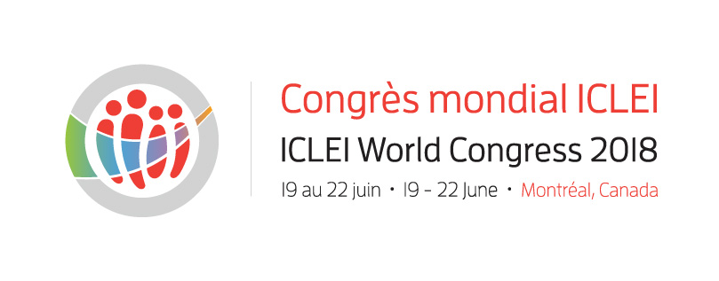
MEDIA ACCREDITATION FORM

ICLEI World Congress– 19 to 22 June 2018

Palais des congrès de Montréal

Eligibility

Media representatives who may be granted accreditation are writing staff/press agencies, photographers and TV/radio crews from one or several of the following groups:
- News papers/magazines that are available to the public, published by an organization whose main activity is publishing;
- Online publications that generate an important quantity of original news and that belong to a registered business, having a verifiable fixed address (non web) and a phone number;
- Press relation services that provide news coverage for registered users, including news papers, periodicals and phone networks;
- Radio and TV media that broadcast information for the public;
- Independent journalists who can provide a recognized media or press card or a letter of employment issued by a media organization.
Technical teams that are not part of the staff of a particular show, members of a non-writing team who work for a media organization, managers, members of the marketing and publicity team, researchers and authors will not be granted accreditation.
Please note that if several of your team members are present at the event, each member must fill out a separate form.

MEDIA passes may be picked up in the press room (Palais des congrès).

Name:
Position / title:
Media:
Web site:
Outreach:
Address:
Tel.:
Cell.:
Email:

Media category:
news paper  weekly/monthly  specialized publication  television | radio  internet  other: specify:
particular needs:
subjects of interest:
co-creation and collaborative governance  nature-based solutions  inclusiveness and reconciliation  sustainable public procurement | circular and social economy  Low-carbon development  healthy and sustainable lifestyles  systemic resilience  Other, specify:
Social media presence: | Twitter – Handle :  Facebook  Linkedin  Other, specify:
The number of accreditations is limited. Therefore, you will be notified at least two weeks before the event whether or not your application was approved. Please check the status of your application before planning your trip.
For more information on international media accreditations, please contact ICLEI Global Communications Team at media@iclei.org, and for information on North-American media accreditations please contact Mélissa Archambault, at +1 514 289-8688, extension 238

